Sennheiserin MD 421 Kompakt palkittiin teknisestä innovaatiosta NAMM TEC -palkinnolla

Legendaarisen mikrofonin uudistettu seuraaja sai tunnustusta innovatiivisuudestaan äänenvahvistuksen kategoriassa

Äänentoiston asiantuntija Sennheiser ilmoitti tänään, että MD 421 Kompakt, kompakti versio legendaarisesta MD 421 -mikrofonista, on voittanut 41. vuotuisen NAMM TEC -palkinnon kategoriassa ”Outstanding Technical Achievement”. Voittajan valitsi joukko alan ammattilaisia ja äänentoiston asiantuntijoita. Palkinto on tunnustus MD 421 Kompaktin kyvylle tarjota suurikalvoista suorituskykyä modernissa ja monikäyttöisessä muodossa.
Lisää alla englanniksi.

The MD 421 Kompakt introduces a streamlined approach to miking, retaining the legendary capsule and sonic DNA of the MD 421-II while significantly reducing the physical footprint. By eliminating the traditional bass roll-off switch — a function now standard in modern mixing desks and DAWs — Sennheiser has created a highly versatile tool optimized for high-density stages and tight studio setups, such as toms, guitar cabs, and horns.

The MD 421 Kompakt has received a NAMM TEC Award | 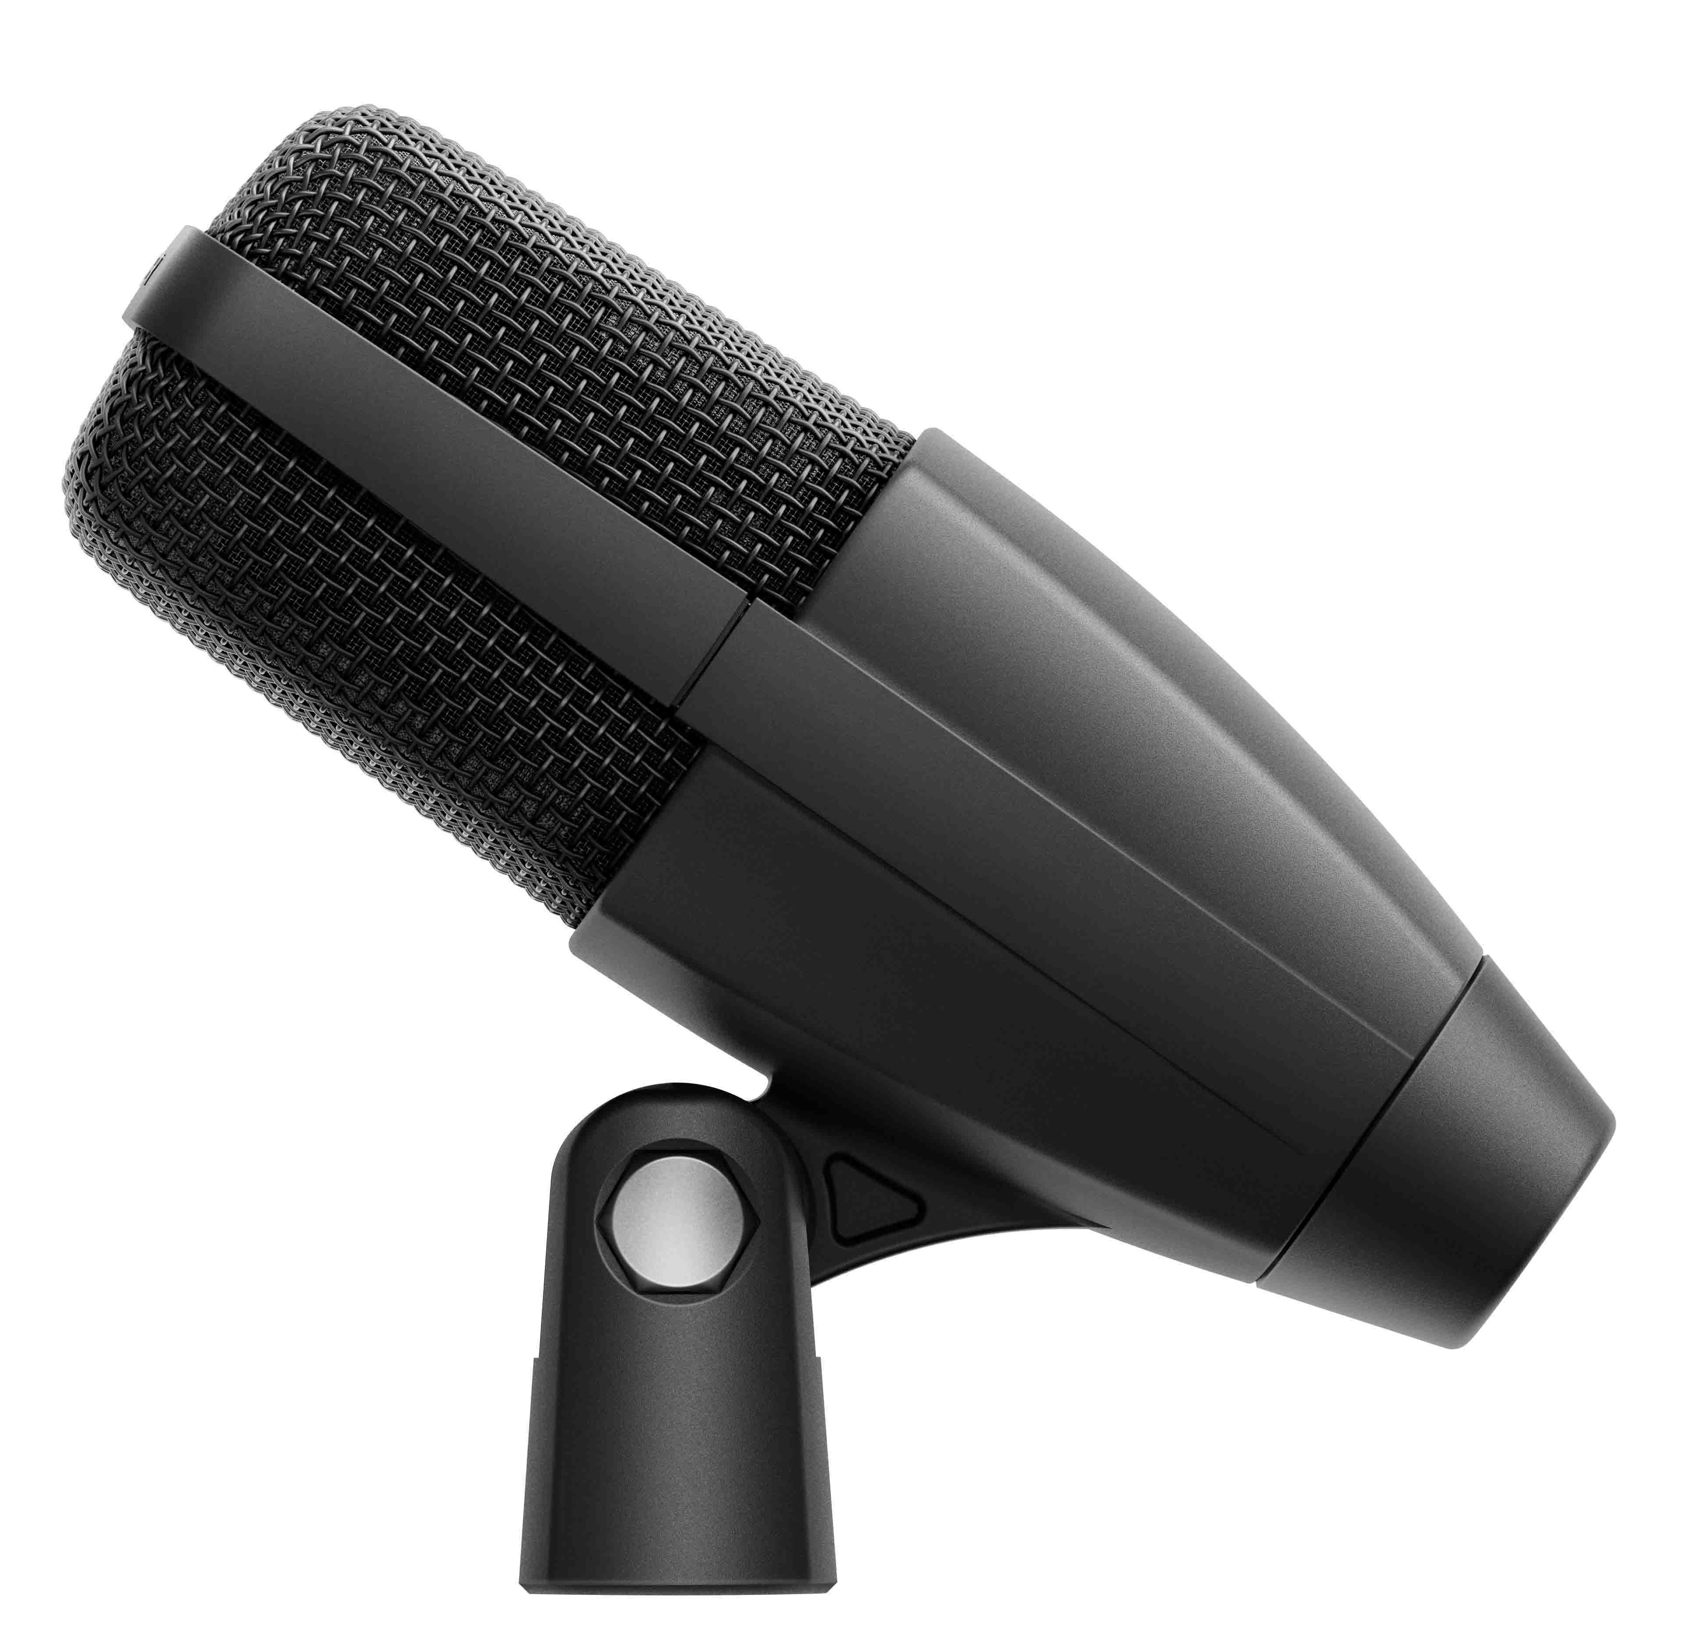

The microphone features a cardioid pick-up pattern and remarkable dynamic range, engineered to handle exceptionally high sound pressure levels in demanding environments. Beyond its sonic performance, the MD 421 Kompakt features an entirely redesigned, integrated mounting clip that addresses long-standing user feedback, providing a fail-safe mounting solution for performers and technicians. This technical recognition at the 41st TEC Awards highlights the microphone’s utility in modern live production and recording applications.

“The MD 421 is a true audio icon, and with the MD 421 Kompakt we continue its legacy while solving real-world challenges for today’s stages and studios,” said Jimmy Landry, Global Category Market Manager, MI at Sennheiser. “Being recognized by the TEC Awards at NAMM celebrates both our heritage and our commitment to exceptional sound.”

 | CEO Dr. Andreas Sennheiser (l.) and Jimmy Landry, Global Category Market Manager, MI

The TEC Awards recognize technical innovations in recordings, live performances, and multimedia. Now in its 41st year, the program honors the products and individuals that contribute to the advancement of audio technology.

(Ends)

About the Sennheiser brand
We live and breathe audio. We are driven by the passion to create audio solutions that make a difference. Building the future of audio and bringing remarkable sound experiences to our customers – this is what the Sennheiser brand has represented for 80 years. While professional audio solutions such as microphones, meeting solutions, streaming technologies and monitoring systems are part of the business of Sennheiser electronic SE & Co. KG, the business with consumer devices such as headphones, soundbars and speech-enhanced hearables is operated by Sonova Holding AG under the license of Sennheiser.

www.sennheiser.com
www.sennheiser-hearing.com

Press contact
Burson Finland Oy (previously Hill and Knowlton)
sennheiser.finland@hkstrategies.com

